Performance report
Acme-Comics

Introduction

In order to evaluate the performance of the project, we split the functional requirements into use cases and developed one JMeter test per use case.

200 concurrent users were used in all tests, as when it was increased above that we got random “Connection closed by peer” type errors in JMeter, at a very low probability, which increased if we increased the number of concurrent users more. Since at 200 users the system was always stable with 0.00% errors, we decided that the system supports a maximum of 200 simultaneous users.

Use case UC1: Register as user
In this use case the user creates an account for himself.
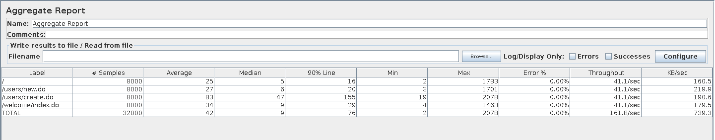
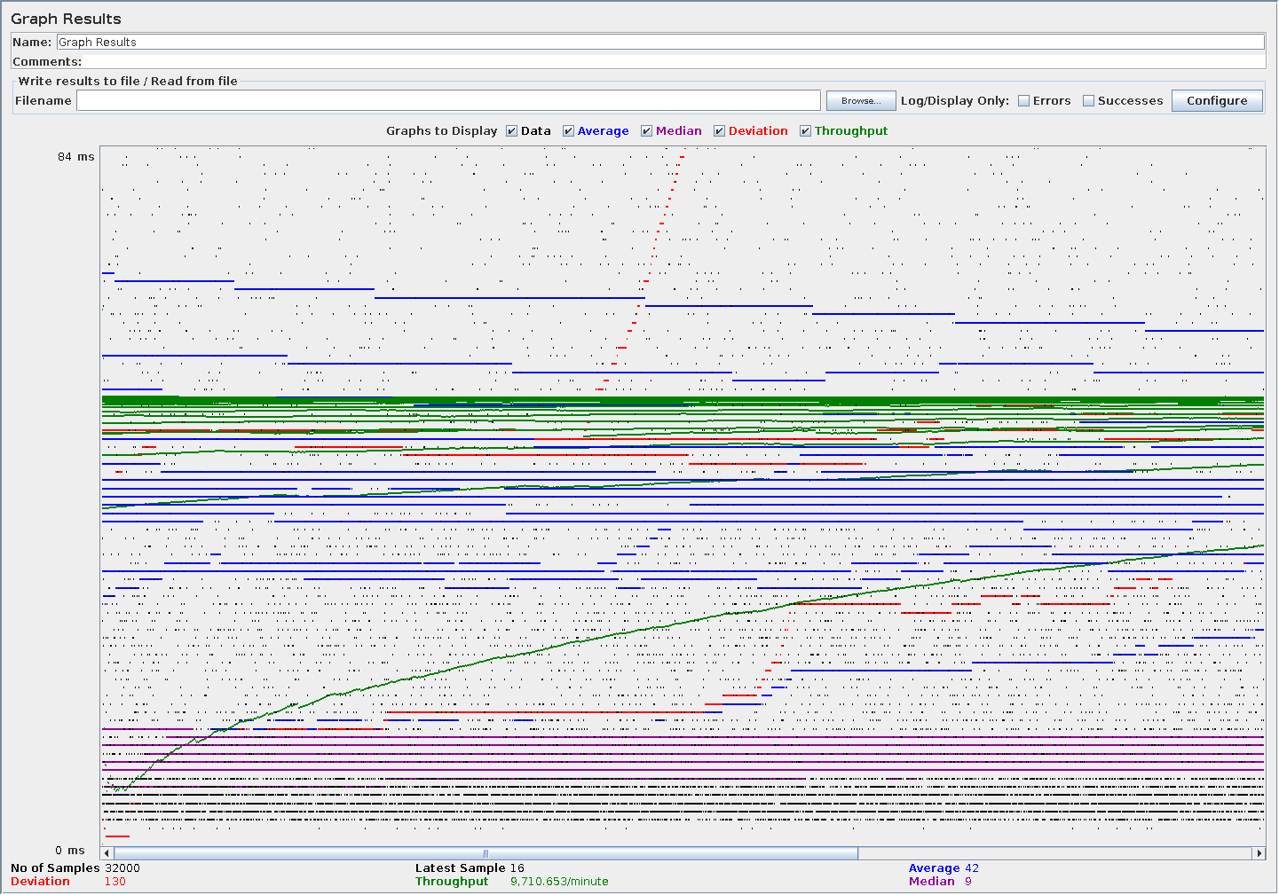

Use case UC2: Comic navigation
In this use case the user lists the available comics, performs a search with a keyword, displays a comic, and changes his status in the comic, his rating of the comic, and marks and unmarks a volume as read.
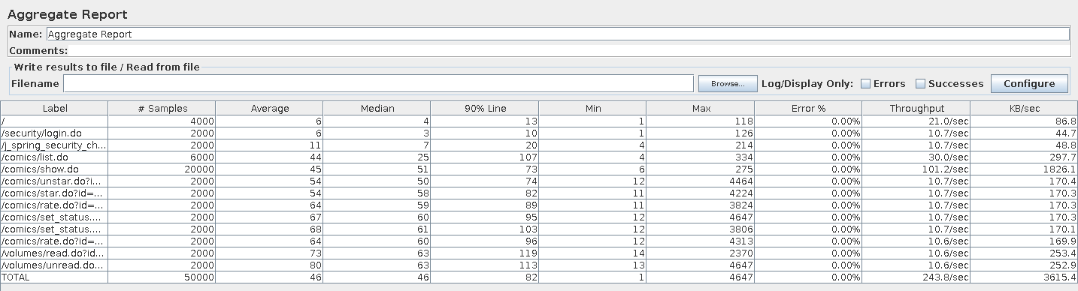
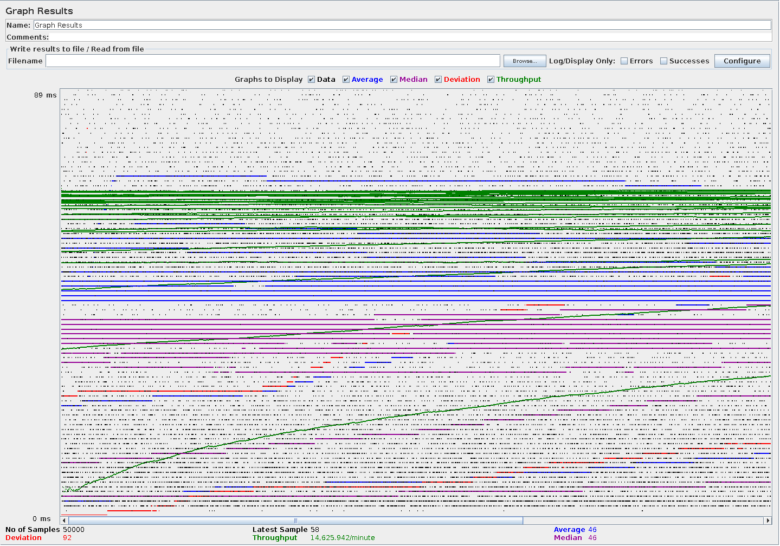

Use case UC3: Comic management
In this use case a trusted user creates a comic, edits it, and deletes it.
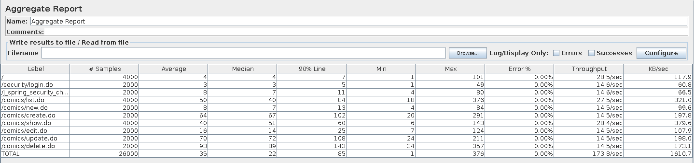
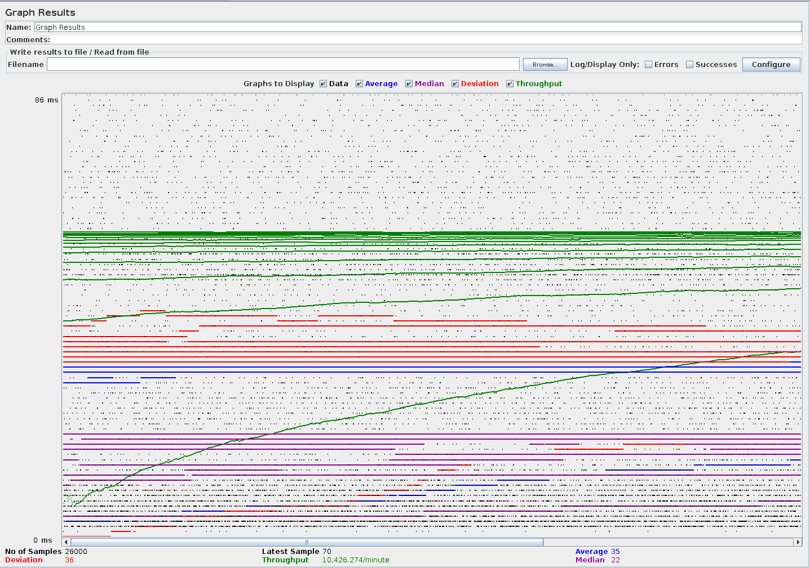

Use case UC4: Publisher management
In this use case a trusted user lists and displays publishers, and creates, edits and finally deletes a new publisher.
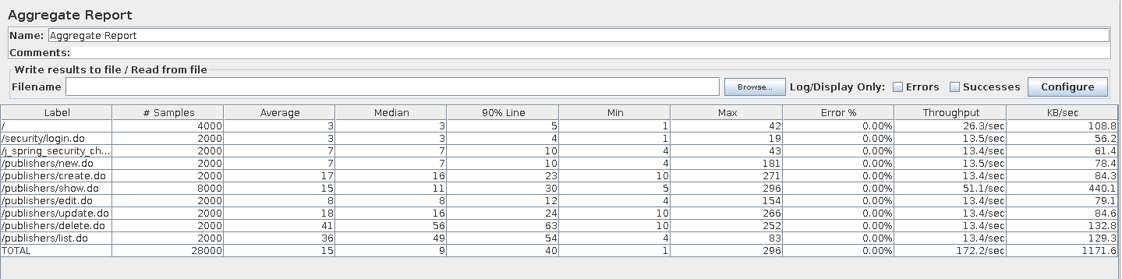
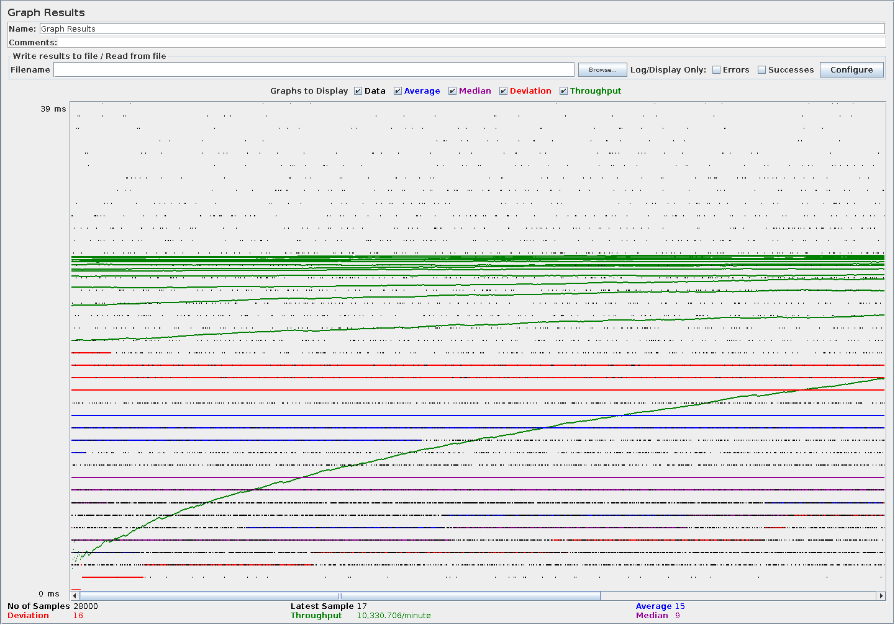

Use case UC5: Author management
In this use case a trusted user lists and displays authors, and creates, edits and finally deletes a new author.
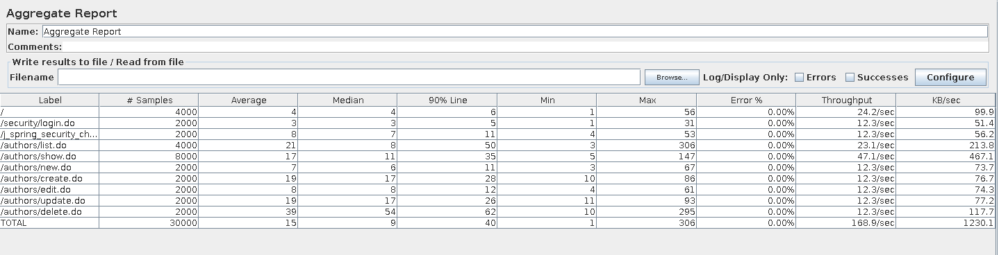
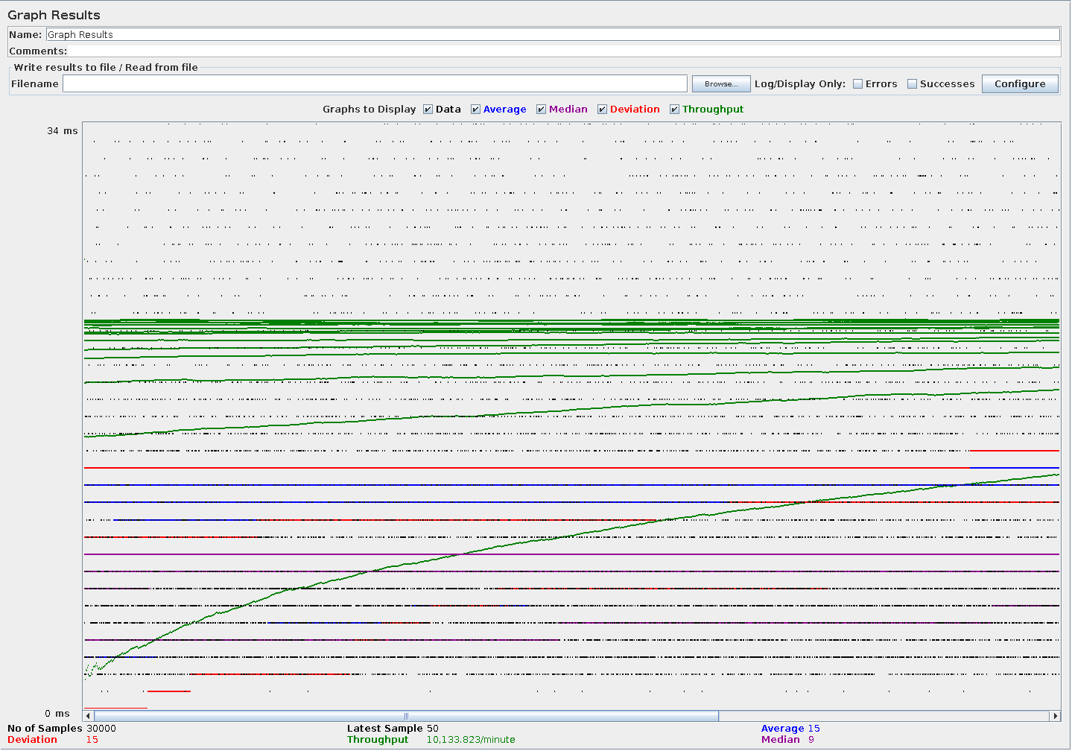

Use case UC6: Comic character management
In this use case a trusted user lists and displays comic characters, and creates, edits and finally deletes a new comic character.
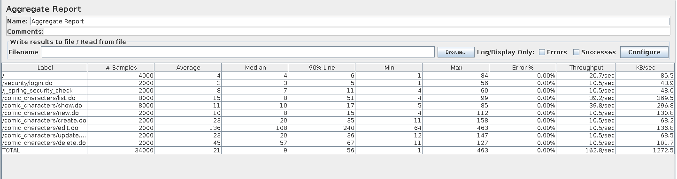
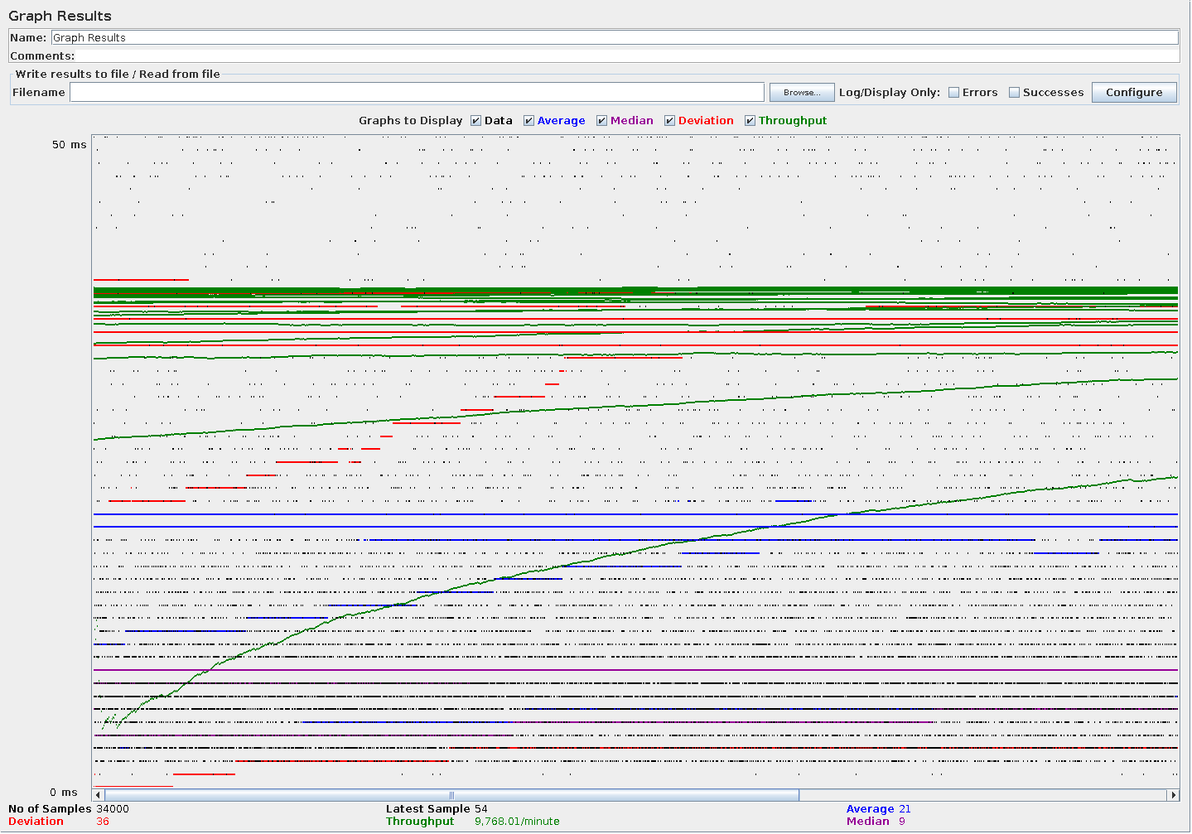

Use case UC7: Comic volume management
In this use case a trusted user displays a comic, which lists the volumes of a comic, and then creates, displays, edits and finally deletes a new comic volume.

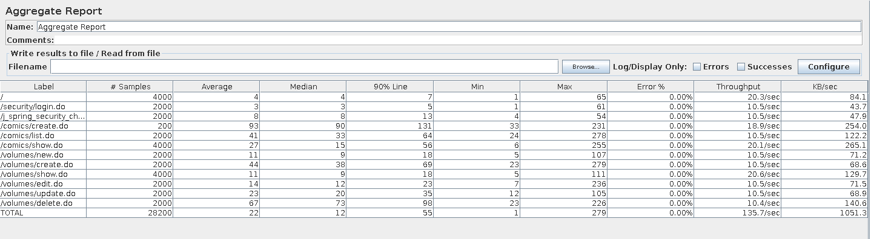
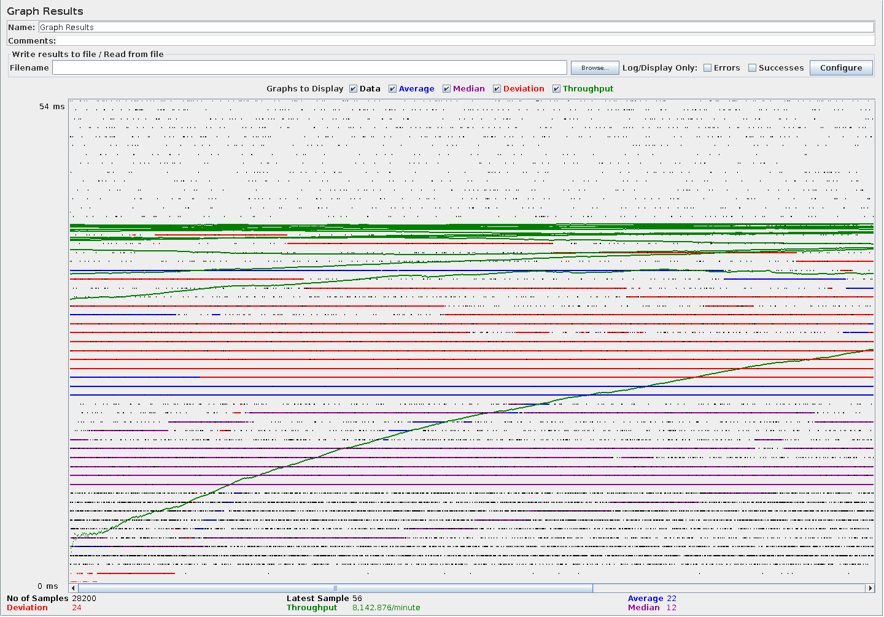

Use case UC8: Friending and unfriending users
In this use case an user repeatedly marks and unmarks a few users as his friends.
For this test, each thread in the JMeter test has it’s own user account (created in the test itself) to prevent optimistic lock errors and prevent contention due to simultaneous writing to the same User.
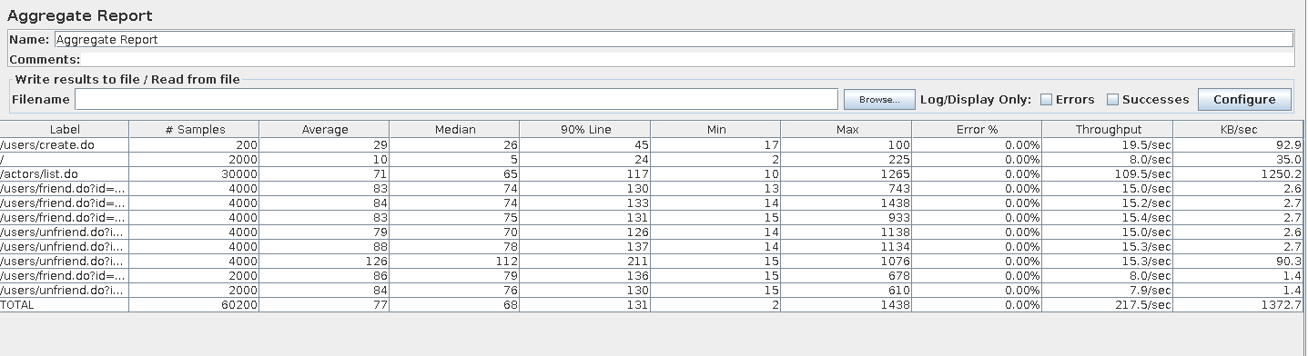
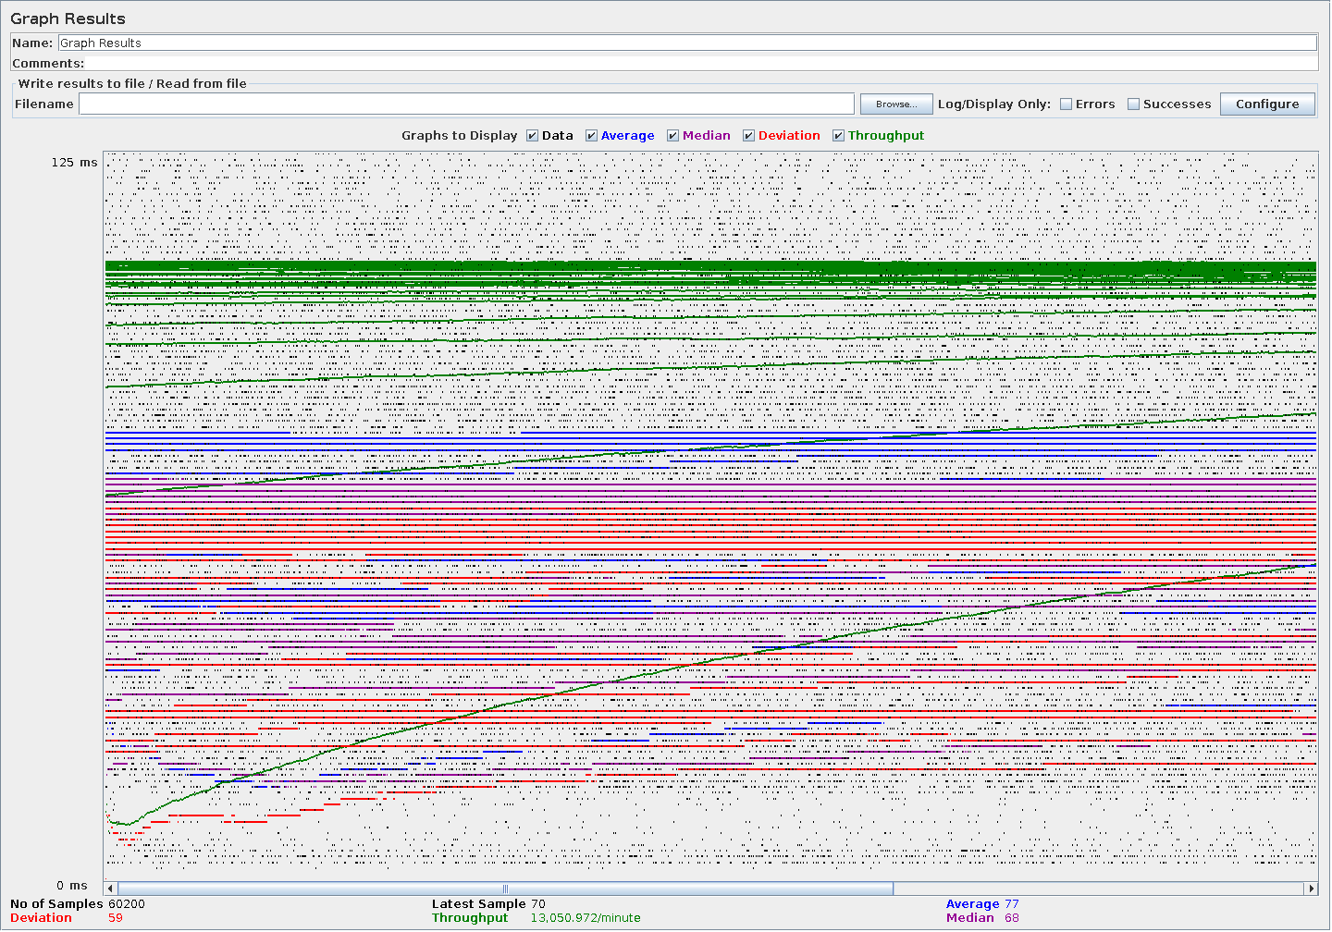

Use case UC9: Trusting and untrusting an user
In this use case an administrator grants and revokes trusted status onto an user.
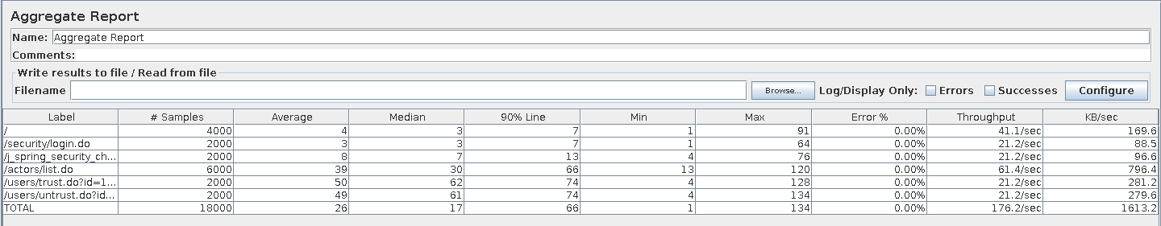
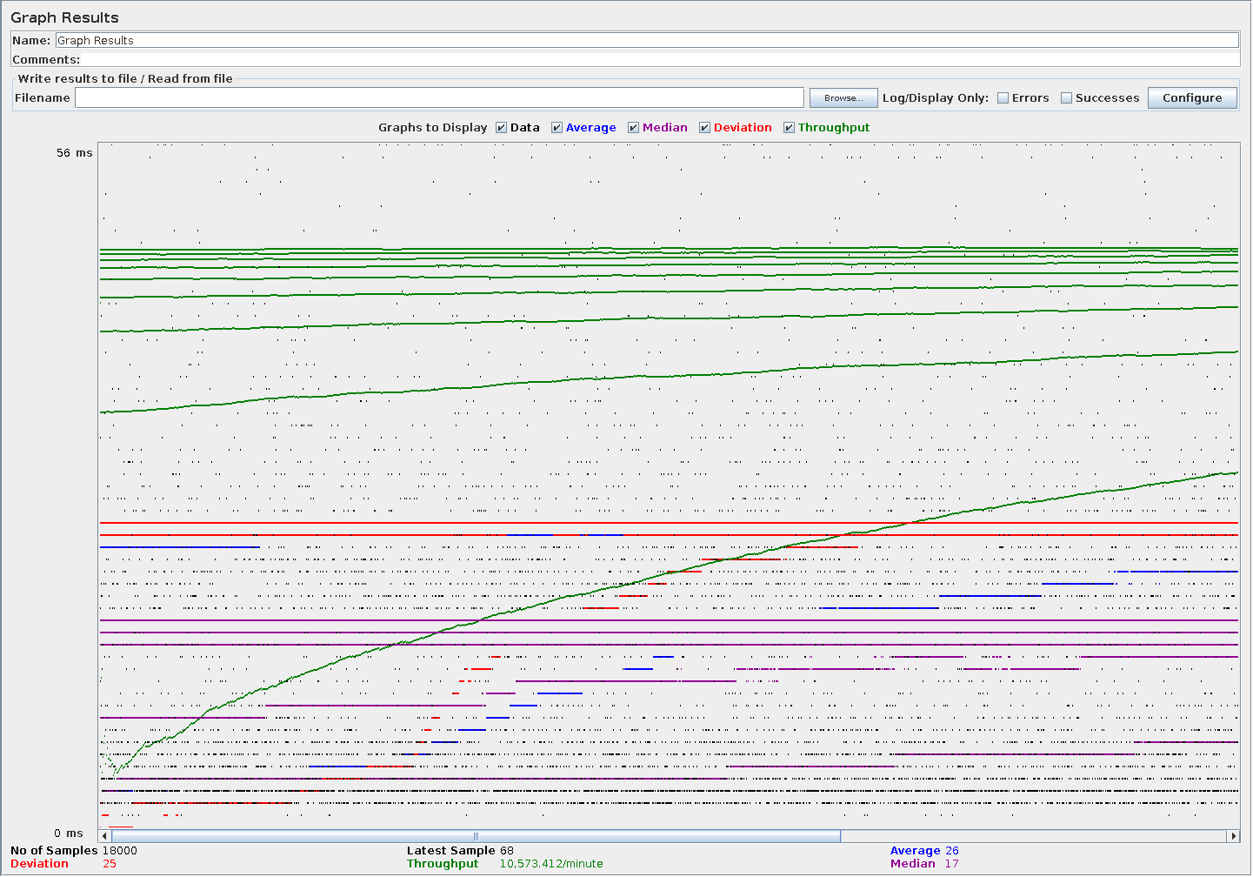

Use case UC10: Blocking and unblocking an user.
In this use case an administrator blocks and unblocks an user from accessing the system.
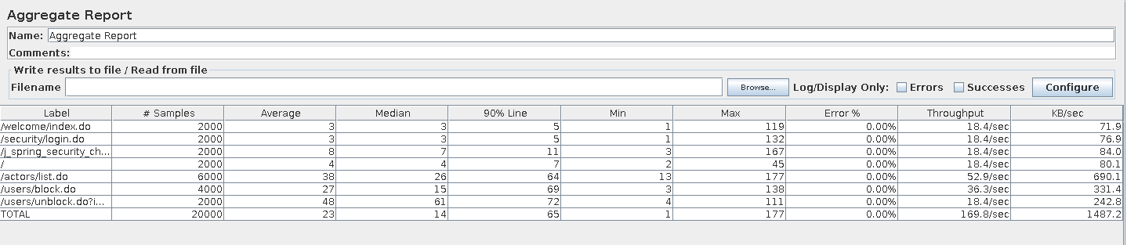
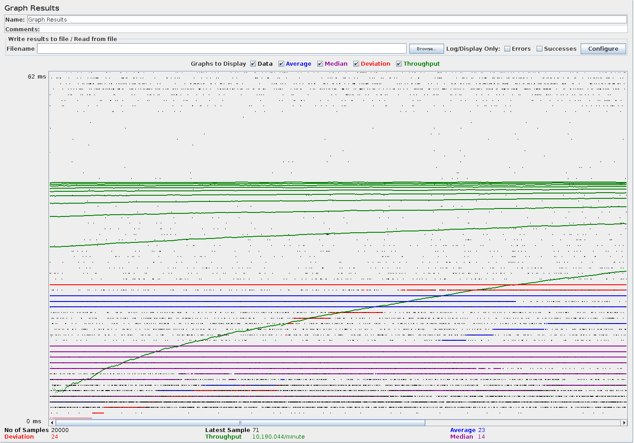

Use case UC11: Sales
In this use case an user lists, creates, displays, updates and cancels a sale, and another user marks himself as interested in another sale.
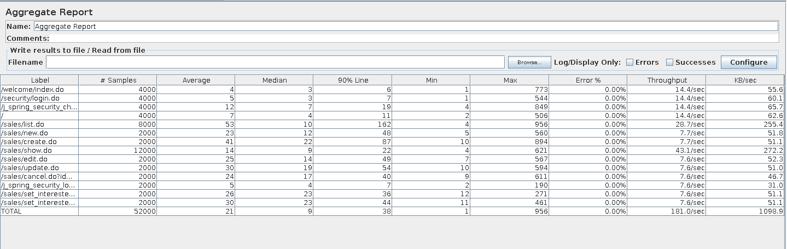
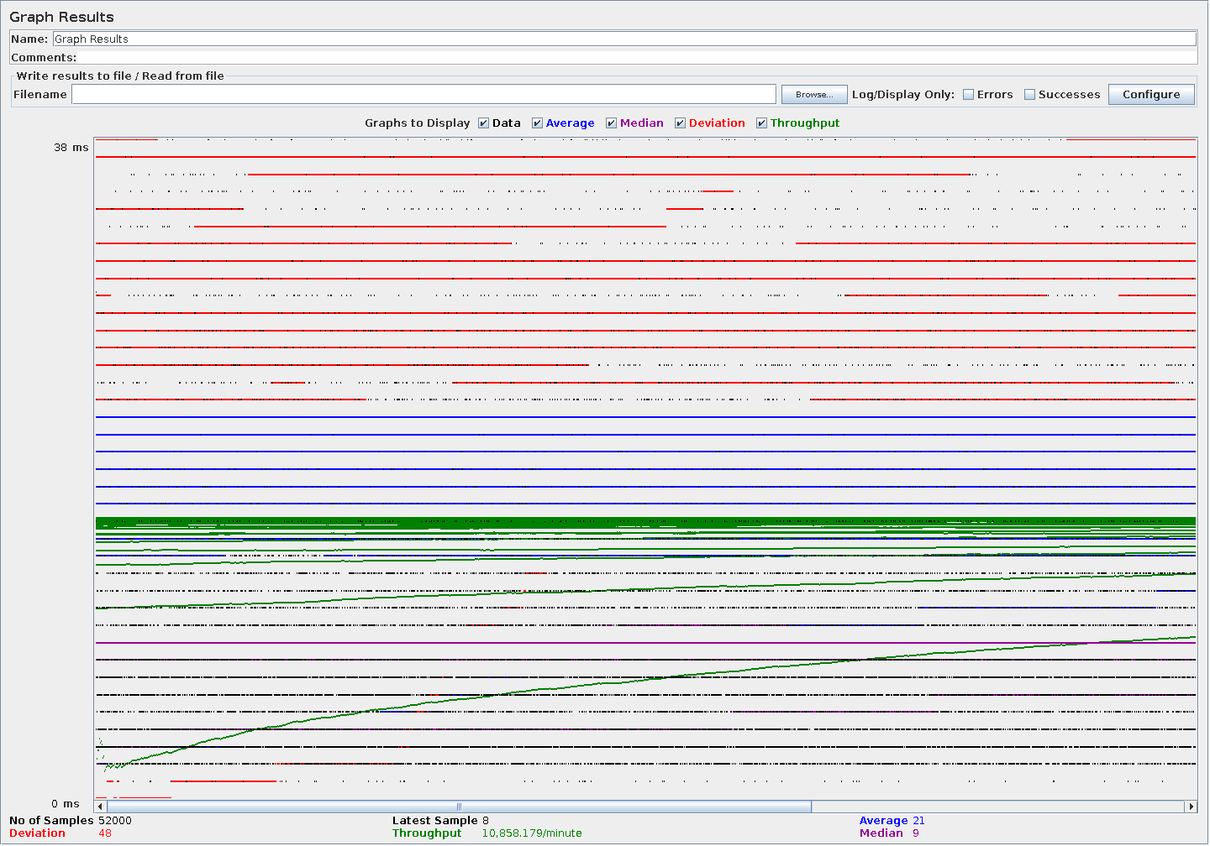

Use case UC12: Direct messages
In this use case an user lists his messages, displays one, sends one, deletes one and moves one from one folder to another.
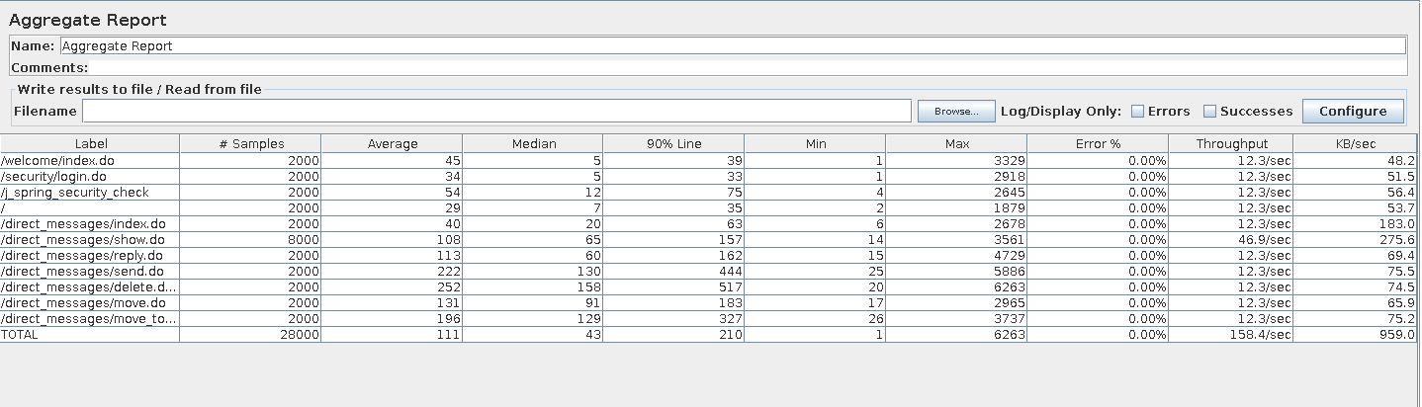
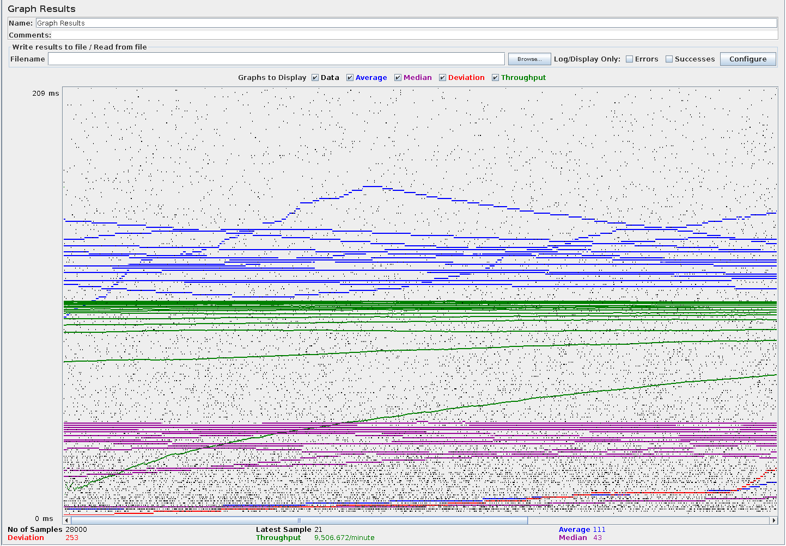

Use case UC13: Direct message folders
In this use case an user creates, edits, and deletes a message folder.
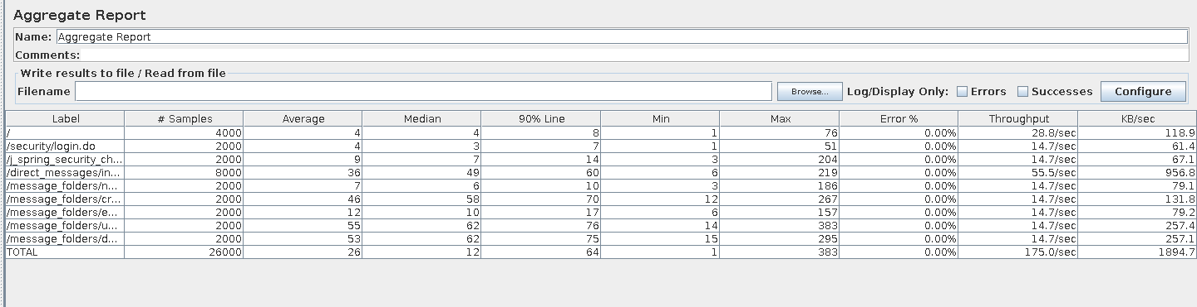
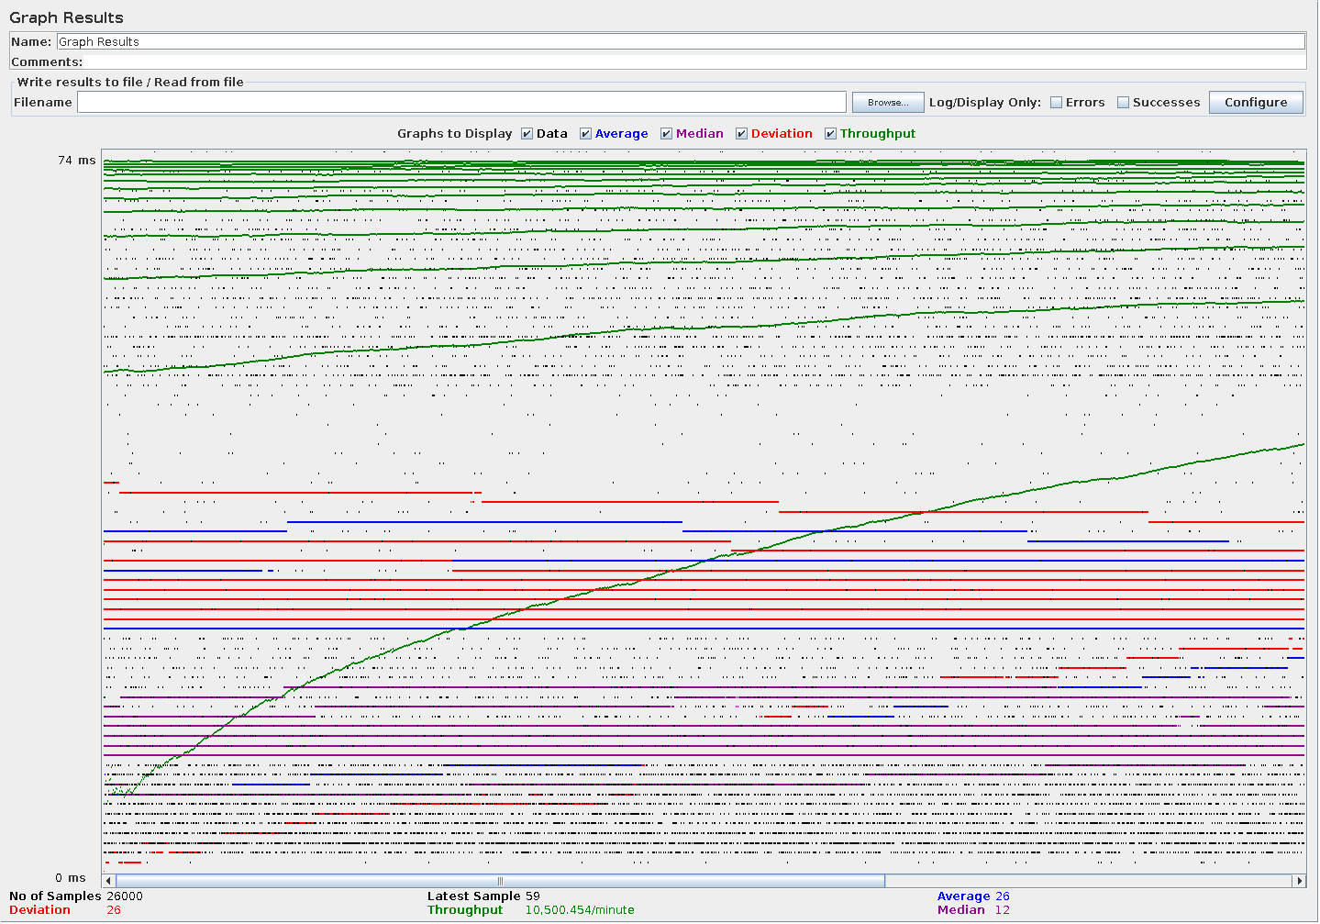

Use case UC14: Comments
In this use case the user writes a comment.
